PROJECT REPORT

PROJECT TEAM
Student No. | Student Names
16138490 | Ben Hill

Kells Group Water Scheme

http://kellsstationkerry.gearhostpreview.com/
https://studentncirl-my.sharepoint.com/:f:/g/personal/x16138490_student_ncirl_ie/EjXnBk07kclCinvgexS5JKYBPFxOmzAUx1Xj5Zq0_1hXiQ?e=ZulsfZ
https://github.com/hillbenhill/KellsGroupWater

Overview

Kells IRD Foilmore and Kells Group Water Scheme
The existing sites are deployed using JOOMLA with on the LAMP stack using traditional webhosting. The Kells Group water scheme requires a simple site to allow users to register and then login to view updates on the group water scheme status.
The longer term plan is to move this static site AWS and use AWS cognito to manage users and to provide federated access i.e facebook or Google login.

Section 1: Design

Research / Investigation

I looked at exiting site and other layout for ideas on how to approach the project. As this was a live client site this first site is really just a prototype. To achieve the requirements no extra Js is need and the site only need to be three pages. I looked at a few options in terms of the development stack and will most likely port the site over to Nxut and then host on AWS using route 53 for the DNS and dynamodb for the backend and cognito to manage users.

Requirements & Technical Approach

The requirements were fairly simple – Provide a static website to allow users to register and login. Registered users once logged in would then have access to additional info not viable to the general public.

Having used Boostrap and other frameworks I decide to use Bumla. Bulma is a mobile first responsive frame work.

Sitemap & Wireframe

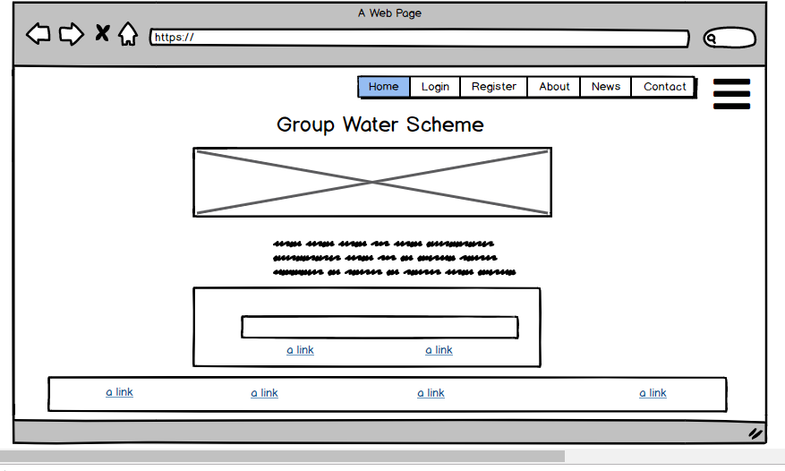
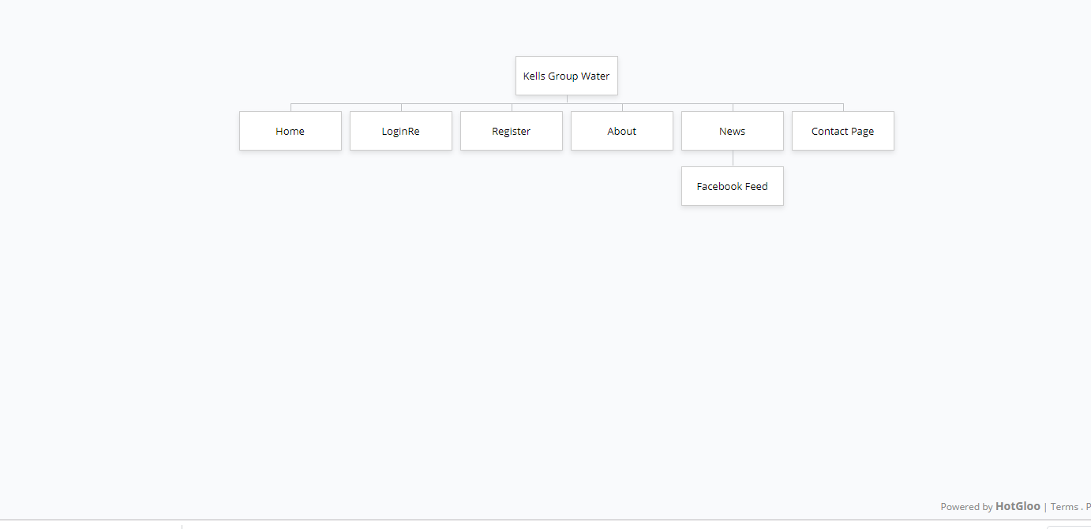
Section 2: Development

My initial approach was to use NUXT.JS but it had steep learning curve given the timescale and work commitments I scaled back to use just HTML5 , CSS and JS.

When using Bulma from a CDN problems with styling were frequent with Firefox. So I decide to to use NPM to add bulma as a project dependency. I also decide to use a continuous deployment process by using git on my local dev environment and then pushing updates to a Github public repository.

The burger NAV menu code and JS code is based off a toggle menu by @Bradcomp
source: https://gist.github.com/Bradcomp/a9ef2ef322a8e8017443b626208999c1

The basic JavaScript included is the date display on the home page, Alert box for terms and condition and a focus onload to bring the user directly to the input box.

Validation & Errors

- Warning: This document appears to be written in English. Consider adding lang="en" (or variant) to the html start tag.
From line 1, column 16; to line 2, column 6
TYPE html>↩<html>↩↩<hea
For further guidance, consult Declaring the overall language of a page and Choosing language tags.
If the HTML checker has misidentified the language of this document, please file an issue report or send e-mail to report the problem.
- Error: Element head is missing a required instance of child element title.
From line 17, column 1; to line 17, column 7
lma.css">↩</head>↩↩<bod
Content model for element head:
If the document is an iframe srcdoc document or if title information is available from a higher-level protocol: Zero or more elements of metadata content, of which no more than one is a title element and no more than one is a base element.
Otherwise: One or more elements of metadata content, of which exactly one is a title element and no more than one is a base element.
- Error: Bad value assets\Images\The_old_station.jpg for attribute src on element img: Backslash ("\") used as path segment delimiter.
From line 63, column 21; to line 63, column 65
<img src="assets\Images\The_old_station.jpg">↩
- Error: An img element must have an alt attribute, except under certain conditions. For details, consult guidance on providing text alternatives for images.
From line 63, column 21; to line 63, column 65
<img src="assets\Images\The_old_station.jpg">↩
- Error: Element a not allowed as child of element ul in this context. (Suppressing further errors from this subtree.)
From line 142, column 29; to line 142, column 65
<ul><a href="http://www.kellskerry.com/">IRD Fo
Contexts in which element a may be used:
Where phrasing content is expected.
Content model for element ul:
Zero or more li and script-supporting elements.
- Error: Element a not allowed as child of element ul in this context. (Suppressing further errors from this subtree.)
From line 147, column 29; to line 147, column 89
<ul><a href="https://kells-bay-house-and-gardens.business.site/">Kells
Contexts in which element a may be used:
Where phrasing content is expected.
Content model for element ul:
Zero or more li and script-supporting elements.
- Error: Element a not allowed as child of element ul in this context. (Suppressing further errors from this subtree.)
From line 152, column 29; to line 152, column 70
<ul><a href="https://www.goldensofkells.com/">Golden
Contexts in which element a may be used:
Where phrasing content is expected.
Content model for element ul:
Zero or more li and script-supporting elements.
- Error: Element a not allowed as child of element ul in this context. (Suppressing further errors from this subtree.)
From line 155, column 29; to line 155, column 68
<ul><a href="http://kellsbaycomputing.com/">Kells
Contexts in which element a may be used:
Where phrasing content is expected.
Content model for element ul:
Zero or more li and script-supporting elements.
- Error: End tag footer seen, but there were open elements.
From line 159, column 9; to line 159, column 17
>↩ </footer>↩</bod
- Error: Unclosed element div.
From line 138, column 13; to line 138, column 36
<div class="container ">↩
- Error: End tag for body seen, but there were unclosed elements.
From line 160, column 1; to line 160, column 7
</footer>↩</body>↩↩</ht
- Error: Unclosed element section.
From line 84, column 5; to line 84, column 31
/div>↩ <section class="container">↩

Validate CSS
and HTML

CSS Parse Error with the minified bulma.css

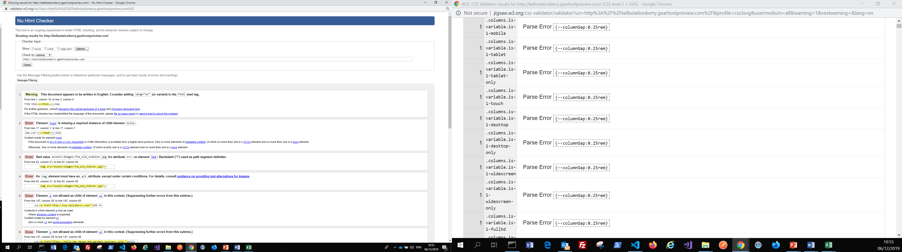
Section 3: Deployment

The site is deployed for the moment on Gear Host using git and github to manage the workflow. Gearhost allows you to switch between versions very easily via the publish cosonsle, this option is not available via ftp. Also using github you could easly deploy via github itself or a raft of other static hosting providers such as netilfy and AWS on a public S3 bucket.

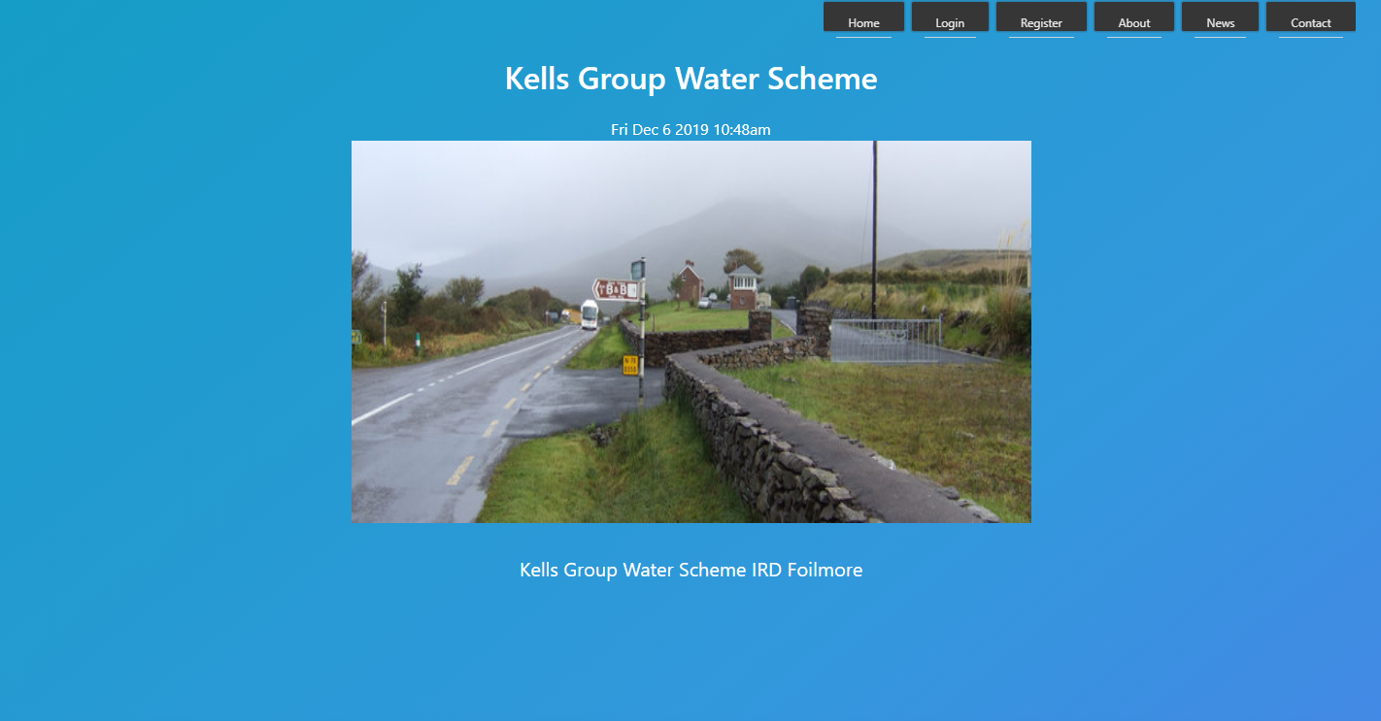

Section 4: User Testing

I used some basic cross browser testing and basic user acceptance testing for the navigation.

The bulk of the testing was manual cross browser testing to see if the layout and responsive elements were consistent across all browsers. The bulma CDN proved to be a bit flakey so I have used in my project as a direct dependancy.

Section 5: Project Team

Ben Hill

Section 6: Conclusion

Using a direct depemdaicy is not best practice I would look to use a build tool such a bower, gulp, webpack to package the project. If I had more time I would deploy as vue / nuxt server side site. The development process with Nuxt can cut down code by using components for the header, footer and hero etc. To connect up to a back on and for user login I would then deploy on AWS S3 using coginito to manage the users

Section 7: References / Appendix

References
Author(s) surname(s), Initial(s). (Year of publication). Title of article. Title of journal, volume number(issue/number, or date/month of publication if volume and issue are absent), page number(s).

W3schools – Javascript , HTML and CSS tutorials - https://www.w3schools.com/
Bulma open source Flexbox CSS framework - https://bulma.io/
W3resource – email validation - https://www.w3resource.com/javascript/form/email-validation.php
Burger Menu - code is based off a toggle menu by @Bradcomp
// source: https://gist.github.com/Bradcomp/a9ef2ef322a8e8017443b626208999c1
How to create a stickey sidebar - https://davidnge.com/blog/how-to-create-sticky-sidebar-navigation/
Bulma Fixed Navbar - https://bulma.io/documentation/components/navbar/#fixed-navbar

